**LAPORAN TUGAS MINGGU 7**

**Polymorphism**

**Pemorgaman Berorientasi Objek**

*Resume ini disusun untuk memenuhi Tugas Mata Kuliah Pemrograman Berorientasi Objek*



Disusun oleh:

Muhammad Rivan Rivaldi 211511048

**PROGRAM STUDI D3 TEKNIK INFORMATIKA**

**JURUSAN TEKNIK KOMPUTER DAN INFORMATIKA**

**POLITEKNIK NEGERI BANDUNG**

**2021**

**Studi Kasus 1. Another Type of Employee**

1. Source Code
2. Employee.java

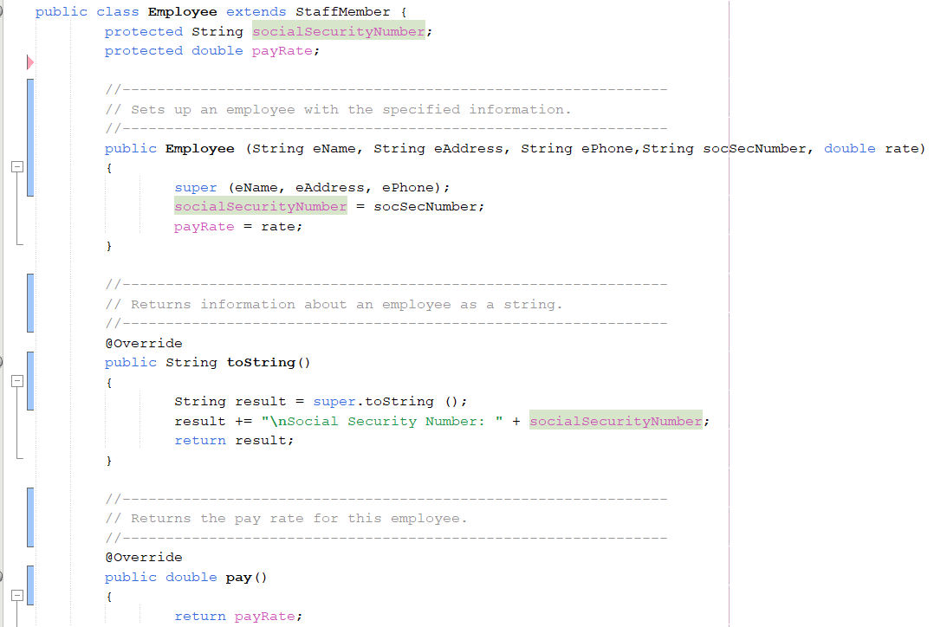



1. Executive.java

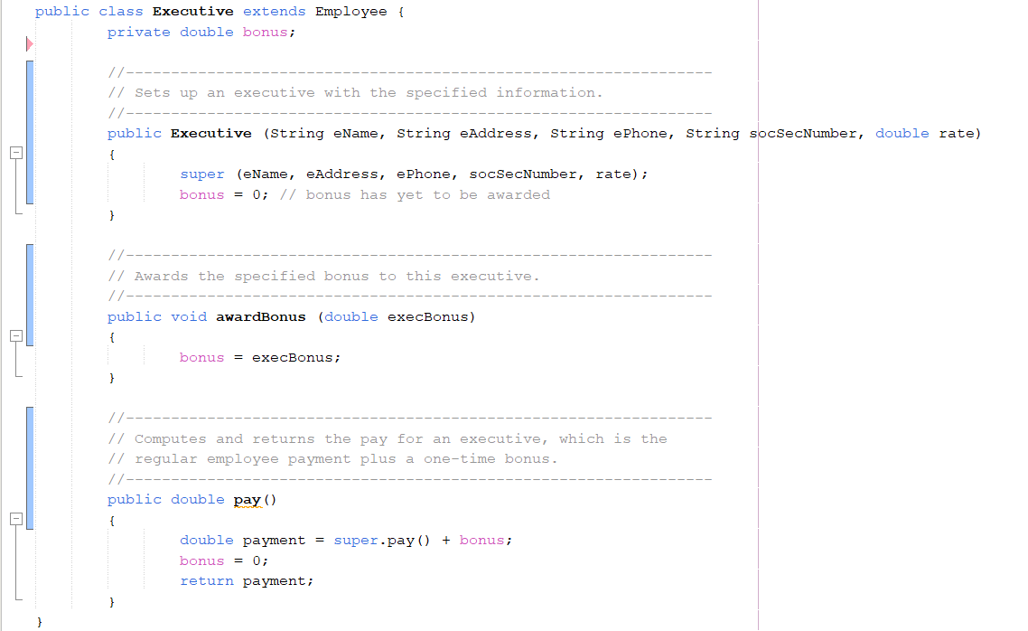

1. Firm.java

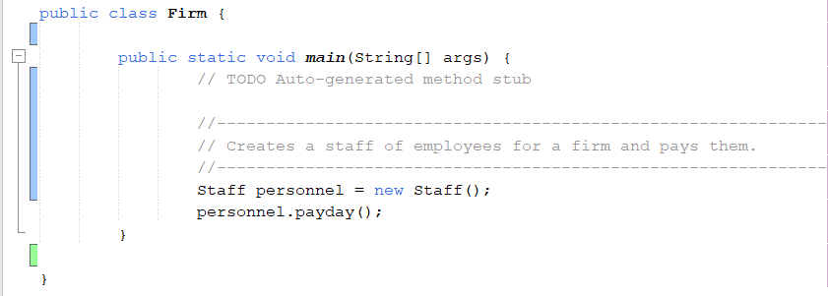

1. Hourly.java

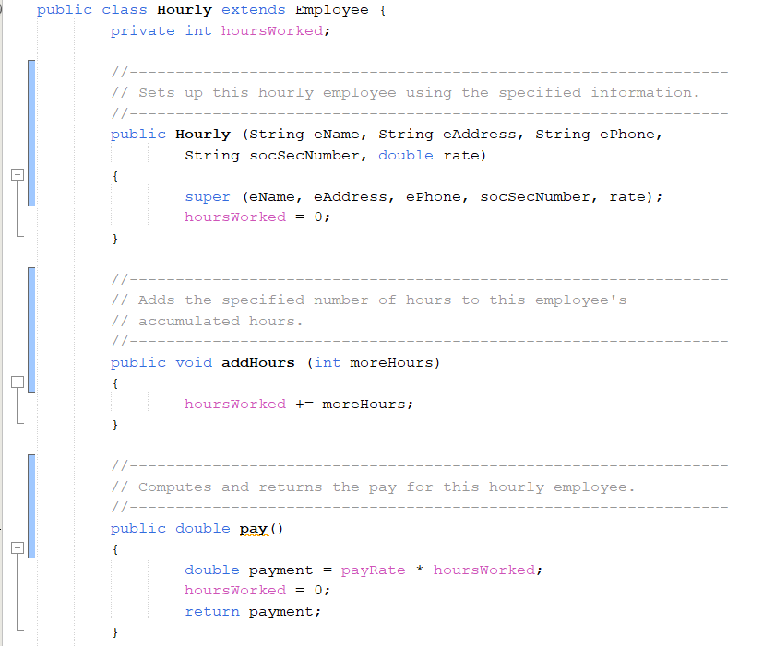

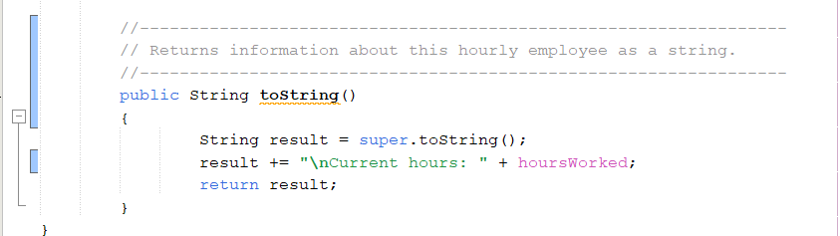

1. Staff.java

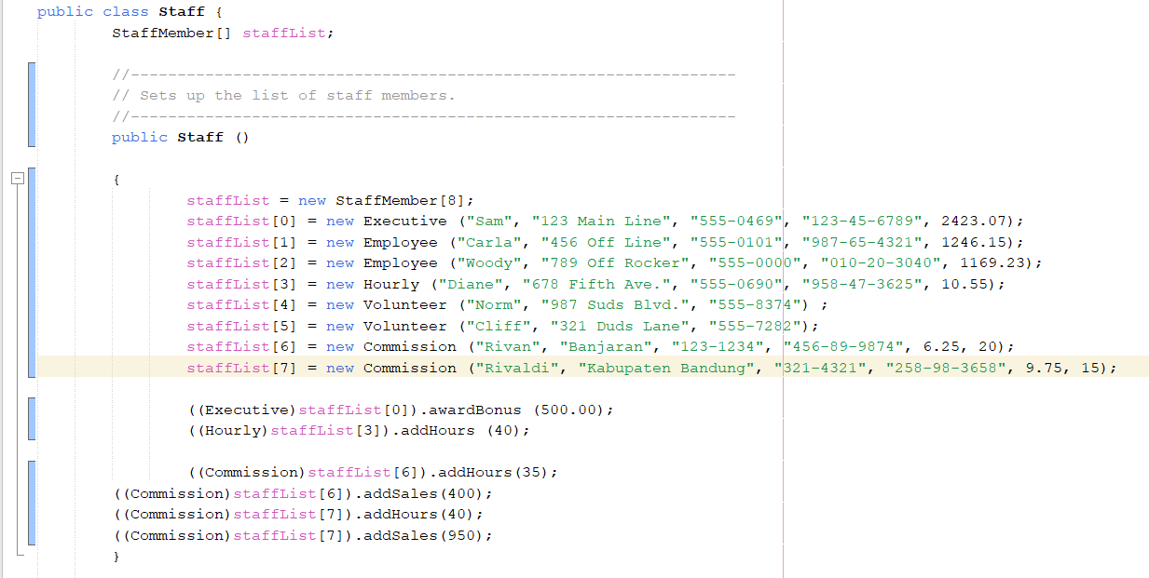

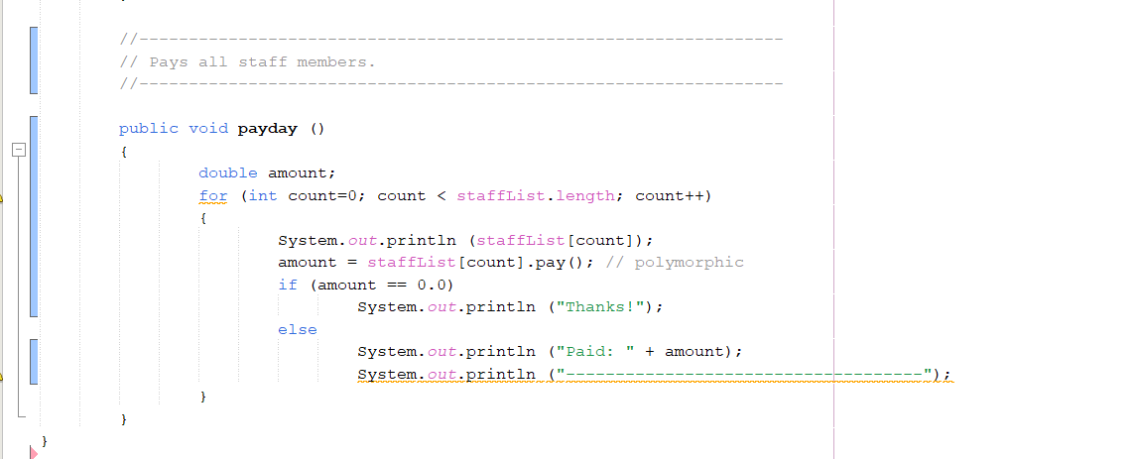

1. StaffMember.java

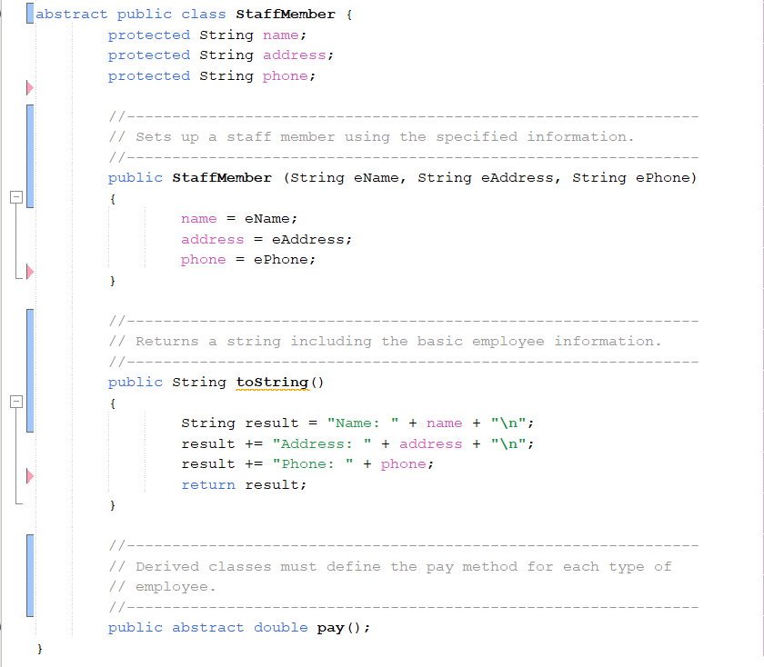

1. Volunteer.java

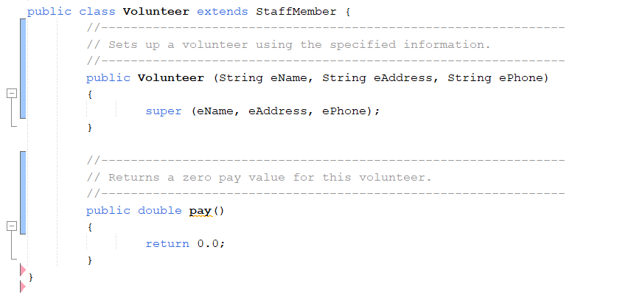

1. Commission.java

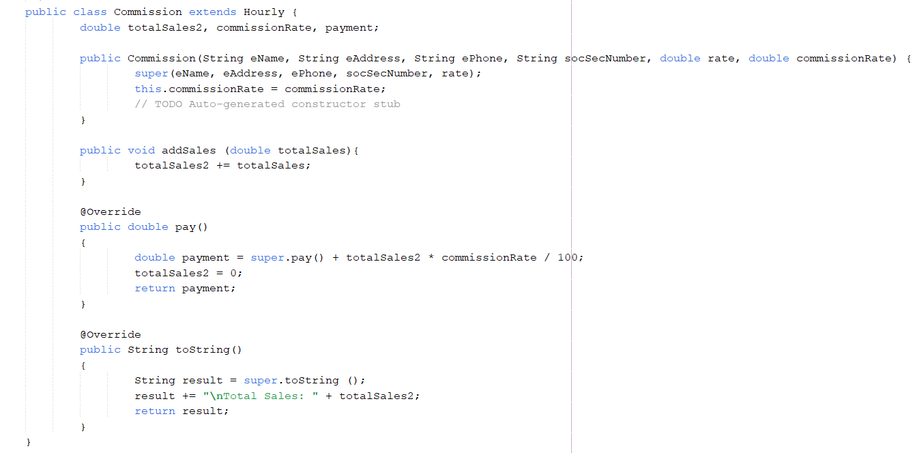

1. Output

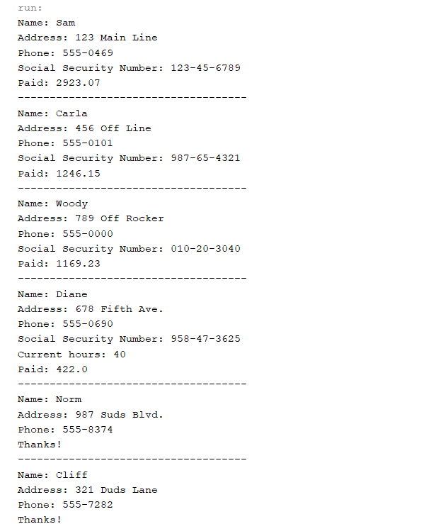

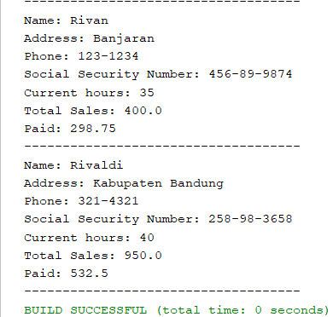

**Studi Kasus 2. Painting Shapes**

1. Source Code
2. Paint.java

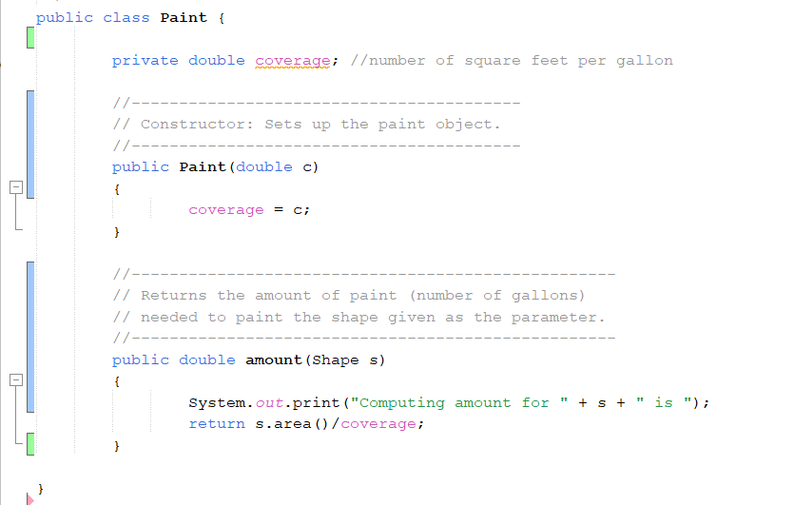

1. PaintThings.java

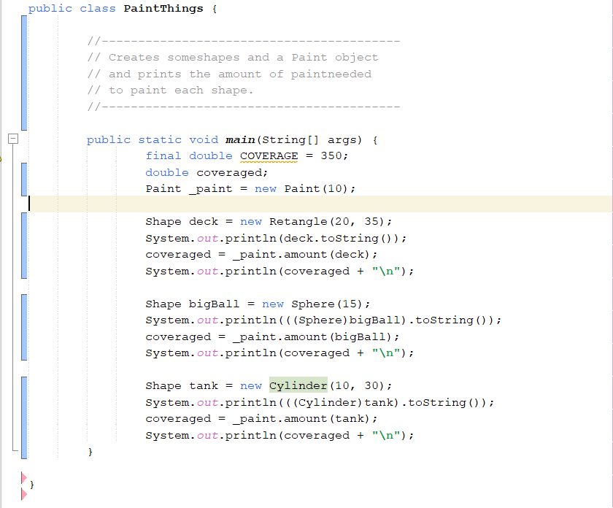

1. Sphere.java

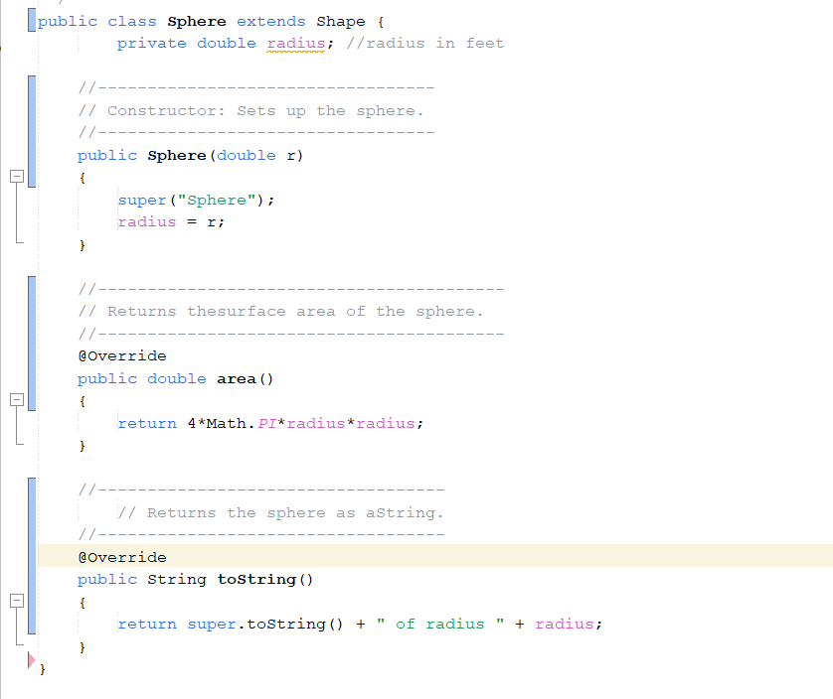

1. Cylinder.java

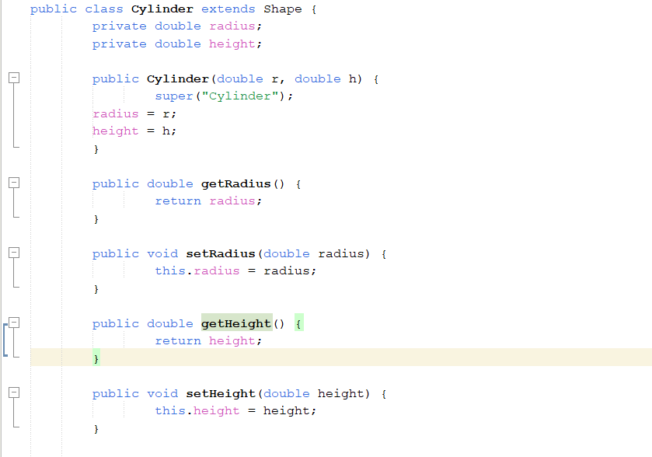

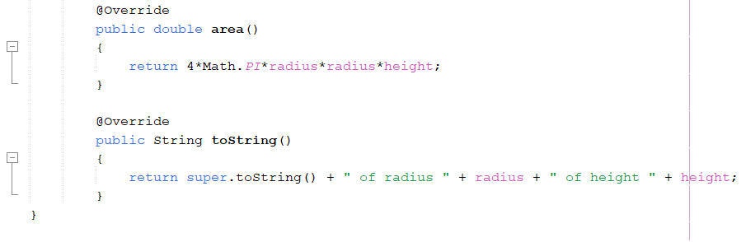

1. Retangle.java

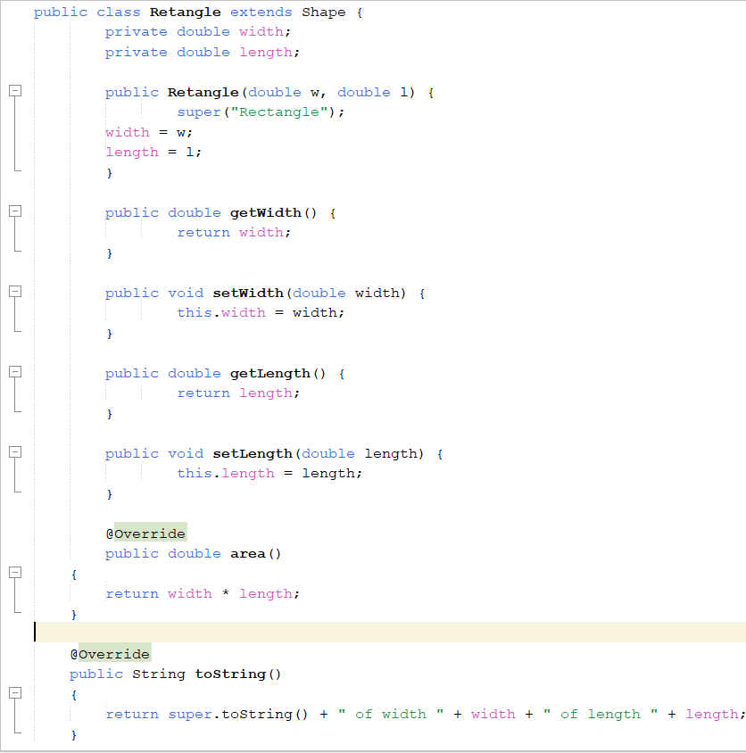

1. Shape.java

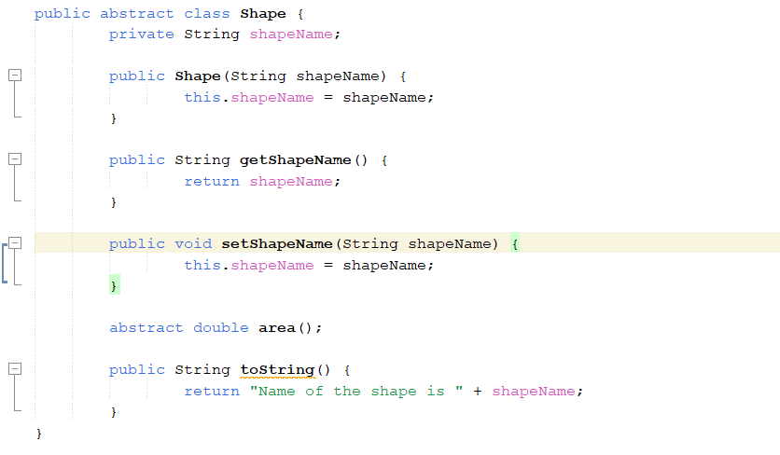

1. Ouput

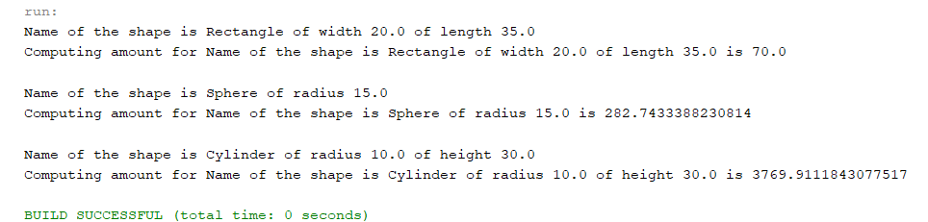

**Studi Kasus 3. Polymorphic Sorting**

1. Source Code
2. Numbers

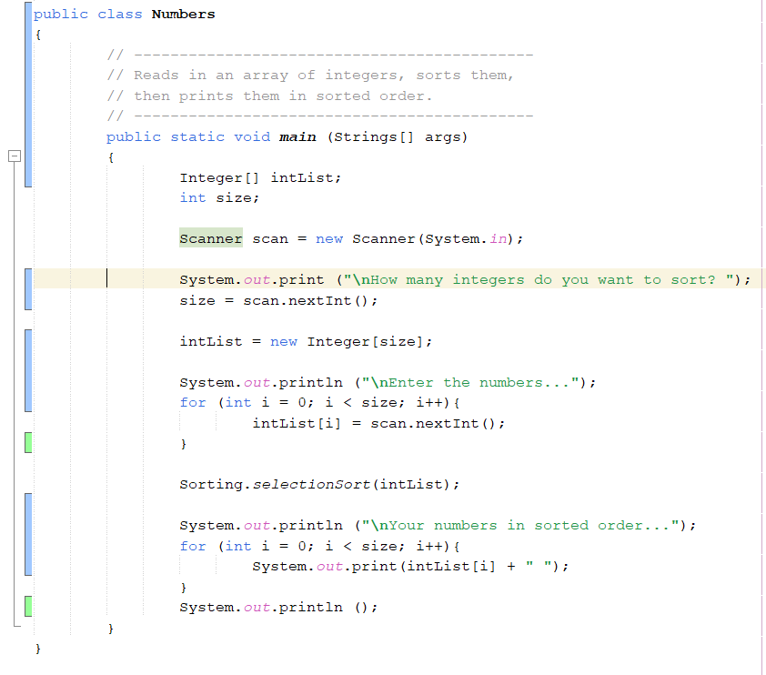

1. Salesperson

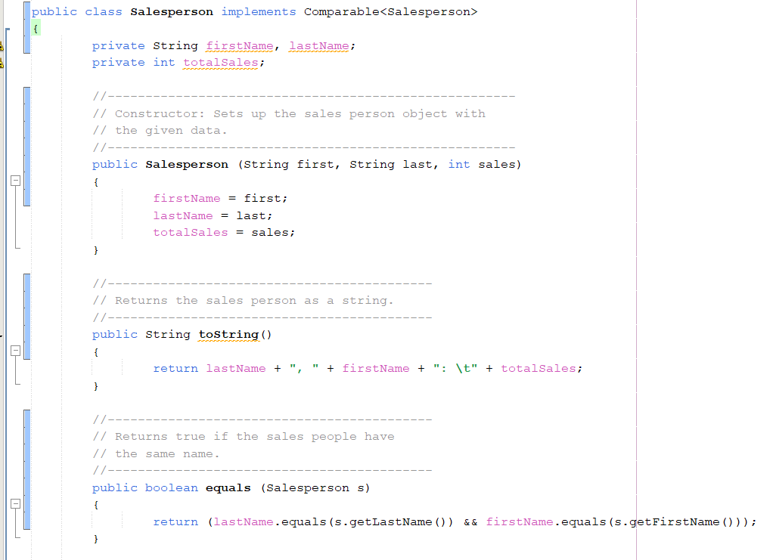

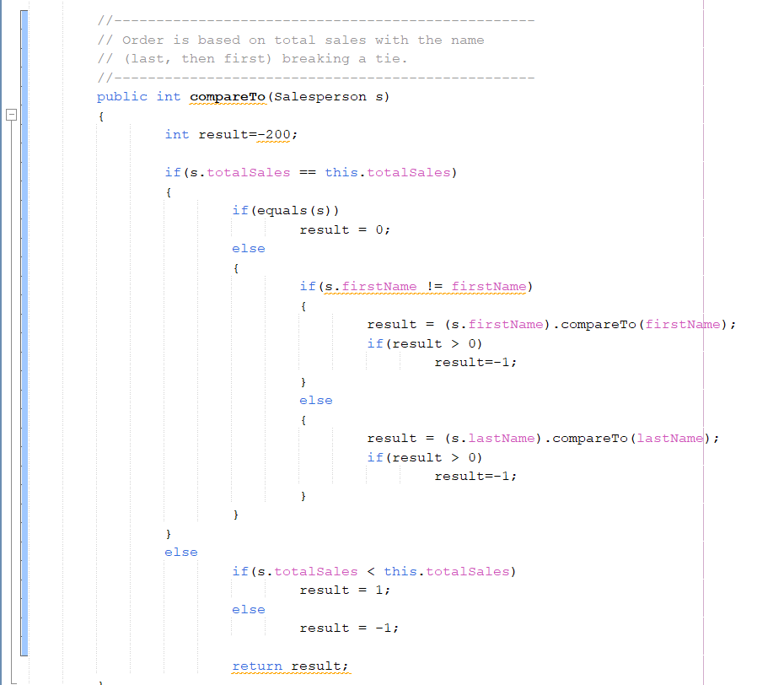

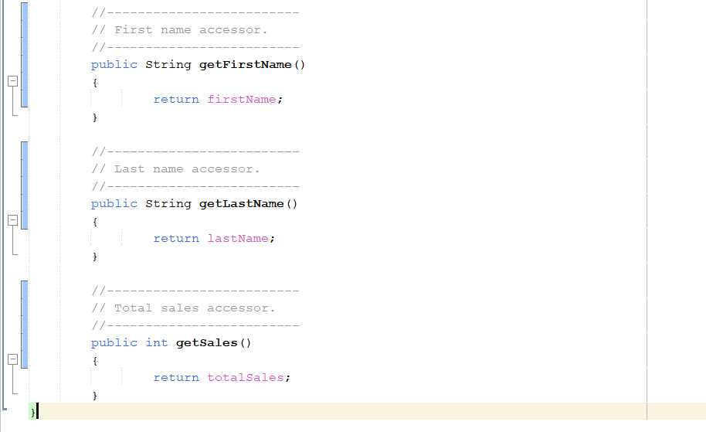

1. Sorting

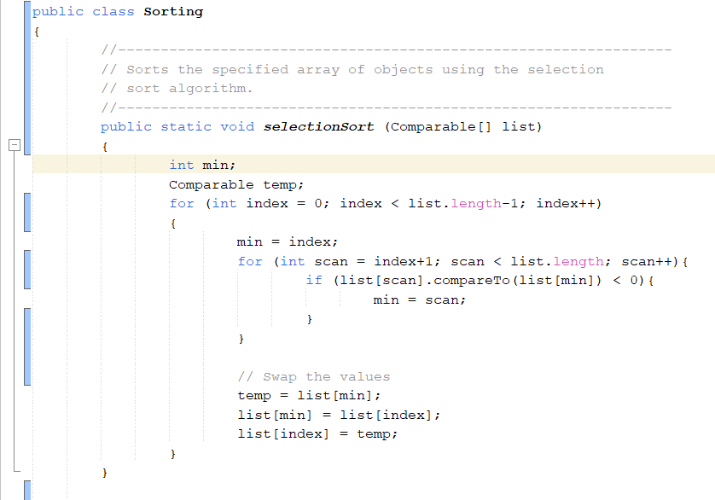

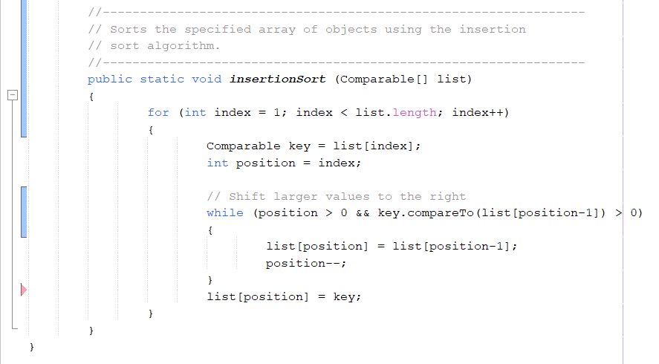

1. WeeklySales

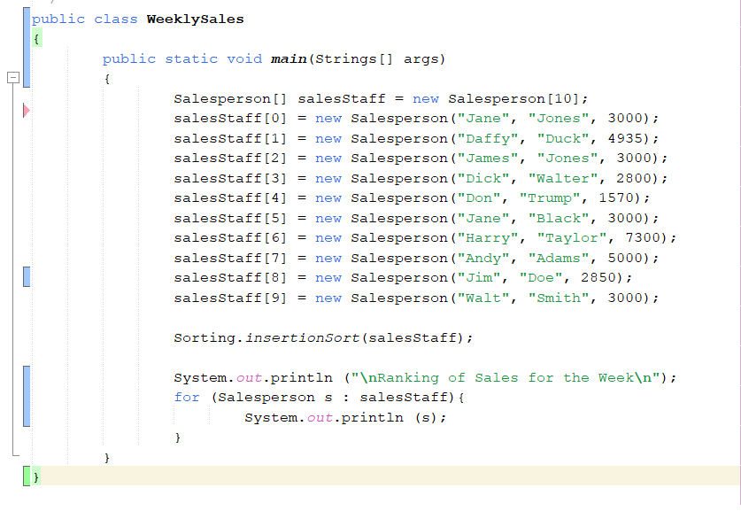

1. Strings

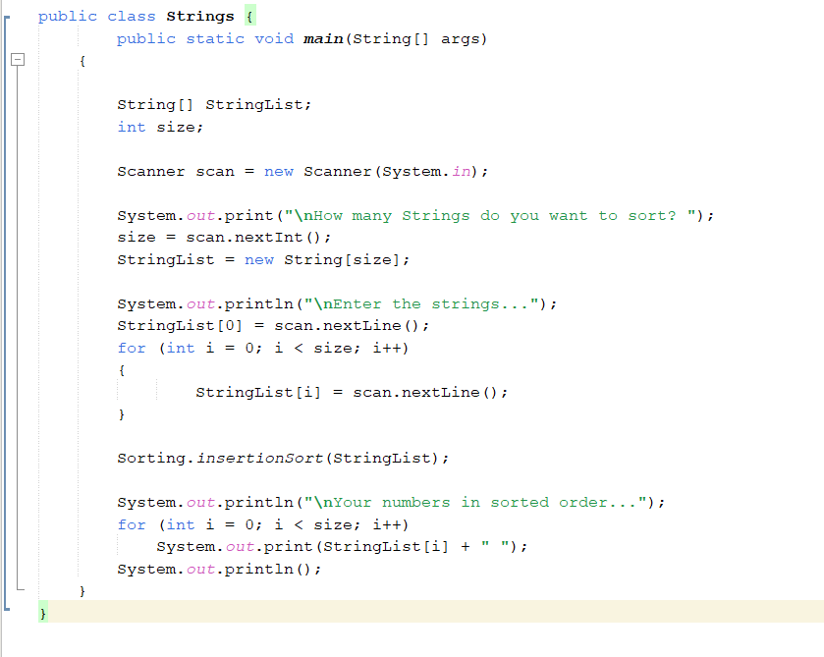

1. Ouput

